Sample J2ME Game 9 – Record MIDlet
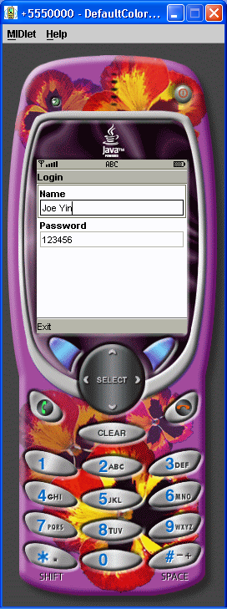

/*
* Wireless Java 2nd edition Jonathan Knudsen Publisher: Apress ISBN: 1590590775
*/
import java.util.Enumeration;
import java.util.Hashtable;
import javax.microedition.lcdui.Command;
import javax.microedition.lcdui.CommandListener;
import javax.microedition.lcdui.Display;
import javax.microedition.lcdui.Displayable;
import javax.microedition.lcdui.Form;
import javax.microedition.lcdui.StringItem;
import javax.microedition.lcdui.TextField;
import javax.microedition.midlet.MIDlet;
import javax.microedition.rms.RecordEnumeration;
import javax.microedition.rms.RecordStore;
import javax.microedition.rms.RecordStoreException;
public class RecordMIDlet extends MIDlet implements CommandListener {
private static final String kUser = "user";
private static final String kPassword = "password";
private Preferences mPreferences;
private Form mForm;
private TextField mUserField, mPasswordField;
public RecordMIDlet() {
try {
mPreferences = new Preferences("preferences");
} catch (RecordStoreException rse) {
mForm = new Form("Exception");
mForm.append(new StringItem(null, rse.toString()));
mForm.addCommand(new Command("Exit", Command.EXIT, 0));
mForm.setCommandListener(this);
return;
}
mForm = new Form("Login");
mUserField = new TextField("Name", mPreferences.get(kUser), 32, 0);
mPasswordField = new TextField("Password", mPreferences.get(kPassword),
32, 0);
mForm.append(mUserField);
mForm.append(mPasswordField);
mForm.addCommand(new Command("Exit", Command.EXIT, 0));
mForm.setCommandListener(this);
}
public void startApp() {
Display.getDisplay(this).setCurrent(mForm);
}
public void pauseApp() {
}
public void destroyApp(boolean unconditional) {
// Save the user name and password.
mPreferences.put(kUser, mUserField.getString());
mPreferences.put(kPassword, mPasswordField.getString());
try {
mPreferences.save();
} catch (RecordStoreException rse) {
}
}
public void commandAction(Command c, Displayable s) {
if (c.getCommandType() == Command.EXIT) {
destroyApp(true);
notifyDestroyed();
}
}
}
class Preferences {
private String mRecordStoreName;
private Hashtable mHashtable;
public Preferences(String recordStoreName) throws RecordStoreException {
mRecordStoreName = recordStoreName;
mHashtable = new Hashtable();
load();
}
public String get(String key) {
return (String) mHashtable.get(key);
}
public void put(String key, String value) {
if (value == null)
value = "";
mHashtable.put(key, value);
}
private void load() throws RecordStoreException {
RecordStore rs = null;
RecordEnumeration re = null;
try {
rs = RecordStore.openRecordStore(mRecordStoreName, true);
re = rs.enumerateRecords(null, null, false);
while (re.hasNextElement()) {
byte[] raw = re.nextRecord();
String pref = new String(raw);
// Parse out the name.
int index = pref.indexOf('|');
String name = pref.substring(0, index);
String value = pref.substring(index + 1);
put(name, value);
}
} finally {
if (re != null)
re.destroy();
if (rs != null)
rs.closeRecordStore();
}
}
public void save() throws RecordStoreException {
RecordStore rs = null;
RecordEnumeration re = null;
try {
rs = RecordStore.openRecordStore(mRecordStoreName, true);
re = rs.enumerateRecords(null, null, false);
// First remove all records, a little clumsy.
while (re.hasNextElement()) {
int id = re.nextRecordId();
rs.deleteRecord(id);
}
// Now save the preferences records.
Enumeration keys = mHashtable.keys();
while (keys.hasMoreElements()) {
String key = (String) keys.nextElement();
String value = get(key);
String pref = key + "|" + value;
byte[] raw = pref.getBytes();
rs.addRecord(raw, 0, raw.length);
}
} finally {
if (re != null)
re.destroy();
if (rs != null)
rs.closeRecordStore();
}
}
}

